

**Online Doctor Appointment**

**Assignment # 3**

**Software Engineering**

**Submitted to**

**Dr. Ebrahim Mansoor / Ghazala Shafi**

**submitted by**

**Hammad Azam Raees (13542)**

**S.M Yawar Abbas (13651)**

**Hadeer Ur Rehman (12413)**

**Danish Ejaz Ahmed (13309)**

**Agha Ahmed Shayan (13858)**

**Functional and Non-Functional Requirements**

The following is the desired functionality of the new system.

Accept of submissions in form of raw patients; perform analysis of financial to authenticate the users of the system. And non-functional requirement includes the following

The system must verify the validate all user input ant user must be notified in case of errors detected in the database, the system should allow room for expansion.

**Entity Relationship (E-R) Diagram**

An entity relationship diagram (ERD) shows the relationships of entity sets stored in a database. An entity in this context is a component of data. In other words, ER diagrams illustrate the logical structure of databases. An entity relationship diagram is a means of visualizing how the information a system produces is related.

**Entity**

Which are represented by rectangle. An entity is an object or concept that has its existence in the real world. It includes all those things about which data is collected. A weak entity is an entity that must defined by a foreign key relationship with another entity as it cannot be uniquely identified by its own attributes alone.

**Attributes**

Which are represented by ovals. A key attribute is the unique, distinguishing characteristic of the entity. For example, an employee's social security number might be the employee's key attribute.

**An Entity Set**

It is a set of entities of the same type that share the same properties, or attributes.

**Process**

A process shows a transformation or manipulation of data flows within the system.

**Actions**

Which are represented by diamond shapes, show how two entities share information in the database.

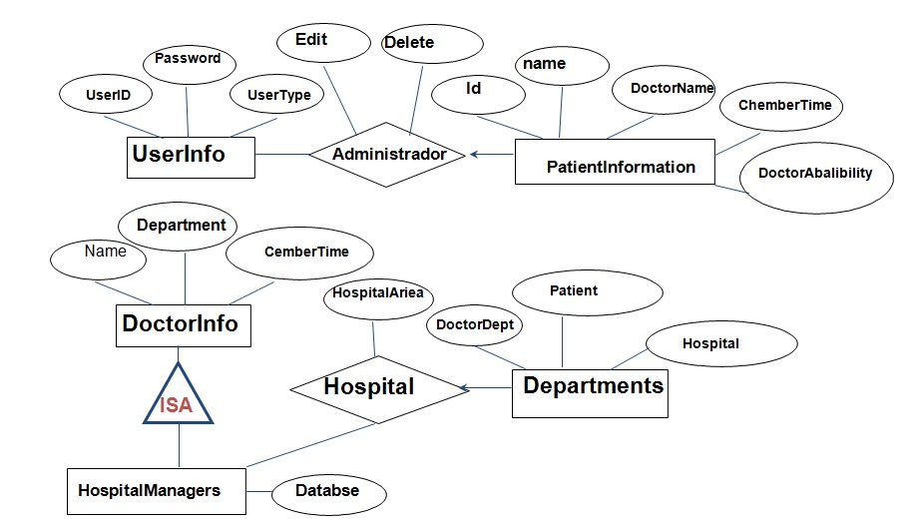

**Use case diagram**



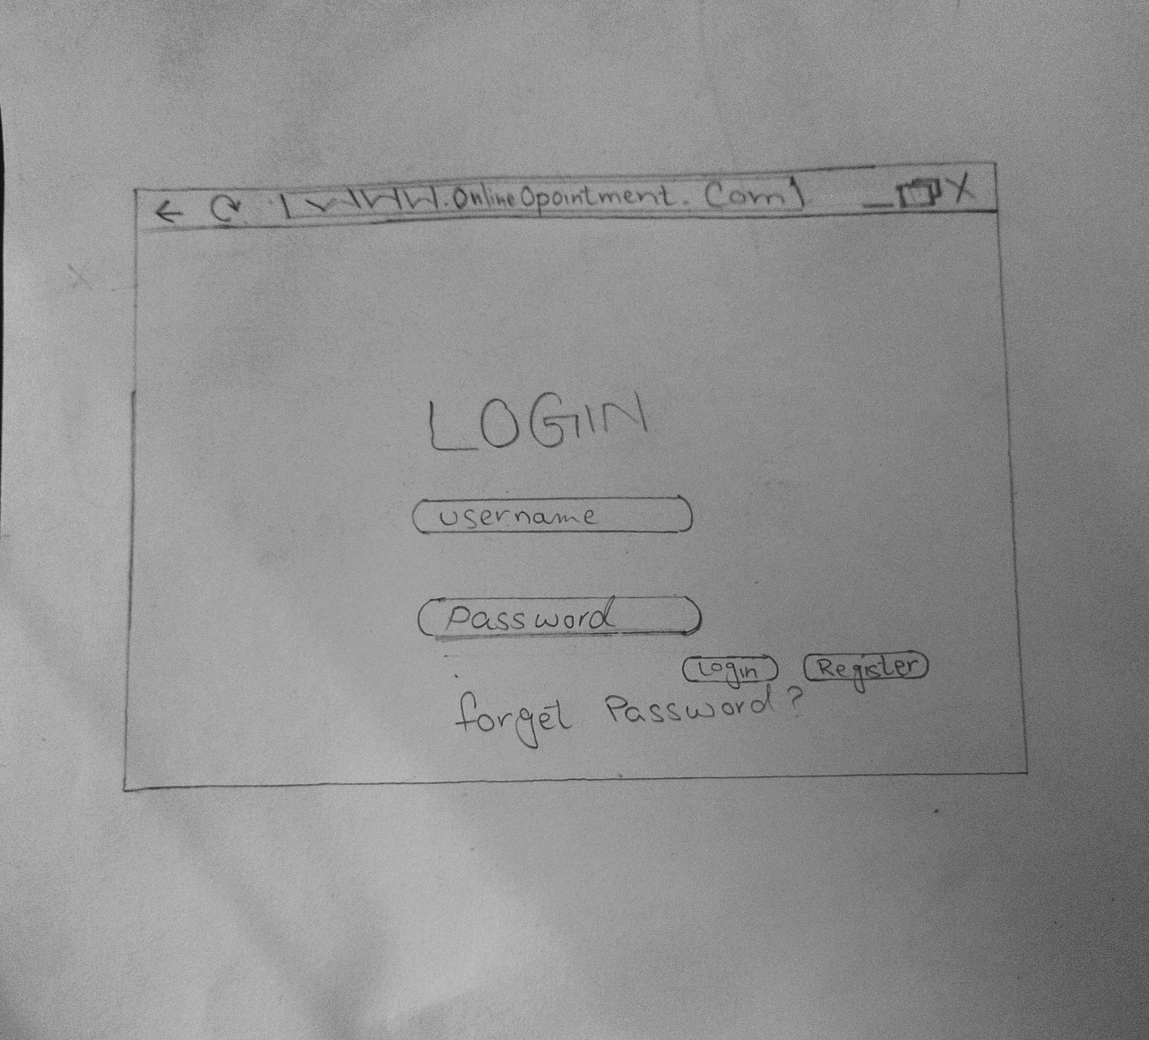**PAPER PROTOTYPE AND WIREFRAMES:**



